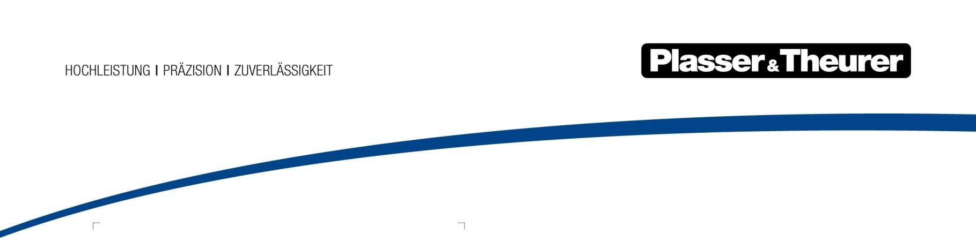

April 2023

Two new machines for Scandinavia

Plasser & Theurer has just signed a contract with RB Solutions for the delivery of two brand new machines for the Scandinavian market.
The two new machines are a Unimat 08-4x4/4S tamping machine, which will be delivered by the end of 2025 (including preparation for the ETCS system and the Iberian track gauge (1,668 mm)) and a USP 2010 SWS universal ballast distributing and profiling machine, which will be delivered in April 2025
RB Solutions has taken this step to reduce the long delivery times on the machine market and to strengthen the Scandinavian area with the best technology on the market. On delivery, the two machines are already approved for Sweden and Norway.
“We see it as a natural development of our long-term commitment in trading with pre-owned machines to start offering new machines ready for operation. In close collaboration with Plasser & Theurer and Plasser Scandinavia, we can deliver approved machines with warranty, training, and service agreements according to the needs of our customers.”
Marthin Lundström, CEO RB Solutions
“RB Solutions is a new Plasser & Theurer customer. In deciding to opt for new machines, it is breaking new ground for the Scandinavian market. This makes the company the first provider to lease track construction and maintenance machines. It is a unique opportunity for infrastructure managers and contractors to use cutting-edge technologies and approved machines and to be able to meet short-term needs.”
Göran Sjöström, Sales Director Partner Sales, Plasser & Theurer

Image | File name | Caption
 | Fig. 1 | From left to right: Peter Sonne (CEO Plasser Scandinavia), Marthin Lundström (CEO RB Solutions) and Göran Sjöström (Sales Director Partner Sales, Plasser & Theurer)

