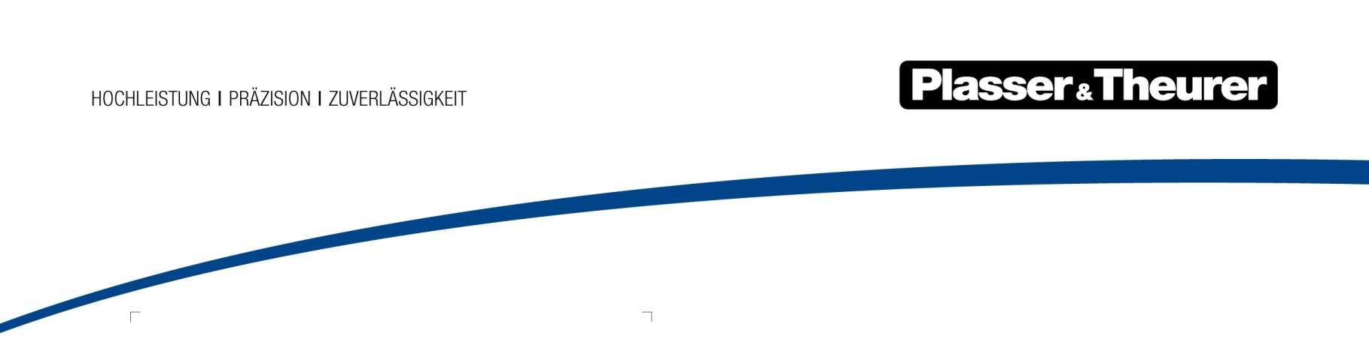

March 2023
First emission-free tamping machine for Scandinavia
Scandinavia plays a pioneering role in climate-friendly behaviour – the field of railway infrastructure maintenance is no exception.
On March 15, Kjersti Kanne, CEO of Baneservice AS, signed a contract in Linz/Austria for Norway’s first E³ machine as a step to make track and turnout maintenance even more environmentally friendly in the future. The E³ track construction and maintenance machines are an innovative product segment of the Austrian manufacturer Plasser & Theurer – E³ standing for “Economic – Ecologic – Ergonomic”. With the new Unimat 09-2X-4x4/4S Dynamic E³, Baneservice AS receives an E³ technology tamping machine with the outstanding feature of having an electric drive. It uses electricity from the overhead contact line (15 kV) for working as well as for driving. The integrated Dynamic Track Stabiliser creates a homogeneous ballast bed and increases resistance against lateral track displacement. Additionally, the sweeping unit ensures a clean finish of track and turnout. For the comfort of the operating staff, the latest cab design includes a heated crew room and a toilet and offers an ergonomic workplace on the tamping machine.
Baneservice is Plasser & Theurer’s largest customer in Norway. In addition to the new Unimat 09-2X-4x4/4S Dynamic E³ the company has placed an order for another machine which will be used for ballast management. The USP 2010 SWS ballast regulator comes with an integrated 10 m³ hopper and the most modern technology available, it ensures an economical use of resources at the worksite. With this machine, a sweeping unit is able to collect and to store existing track ballast and to relocate it wherever required, immediatelay during maintenance work. The machines will be used for maintaining the 4,200 km of track in Norway and will contribute to improved safety and reliability for railway users and staff. With the ETCS train protection system and the coordination of the authorisation process, Plasser & Theurer delivers the new track construction and maintenance machine as a turnkey product for emission-free work on the track.

Image | File name | Caption
 | Fig. 1 | On March 15, Kjersti Kanne (CEO of Baneservice AS) and Johannes Max-Theurer (CEO of Plasser & Theurer) signed a contract for an emission-free future of Norway’s railway infrastructure maintenance.
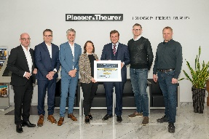 | Fig. 2 | From left to right: Marthin Lundström (RB Solutions/P&T Agent Sweden & Norway), Peter Sonne (CEO Plasser Scandinavia), Göran Sjöström (Sales Director Plasser & Theurer), Kjersti Kanne (CEO Baneservice AS), Johannes Max-Theurer (CEO Plasser & Theurer), Daniel Hatcher (Baneservice AS), Hans Waagen (Baneservice AS)

Plasser & Theurer in brief
- Founded in 1953
- Around 2,000 staff members in Austria
- Around 5,000 staff members worldwide, at 22 partner firms throughout the world and in Austria
- Range of products: machines and systems for laying and installing, renewing, and maintaining tracks and overhead contact lines
- More than 17,000 heavy-duty machines supplied to 110 countries
- Export rate of 93 %
- Main factory in Linz, head office in Vienna
- Service, repair, and spare parts depots all over the world
- Largest sale markets overall: Germany, USA, UK, India, Japan, France, Austria, Brazil, Spain, Australia
- Customers: railway operators, construction firms, urban transport authorities, industrial and mine railways
- More than 2,500 active patents
- 14 international certificates/qualifications (such as ISO 9001:2015, ISO 14001:2015, ISO 37001:2016, ISO 37301:2021, ISO 45001:2018, ISO 50001:2018)

contact:
Plasser & Theurer, Export von Bahnbaumaschinen Gesellschaft m. b. H.
1010 Wien, Johannesgasse 3
Phone: +43 1 51572-0
Fax: +43 1 5131801
Email: presse@plassertheurer.com
https://www.plassertheurer.com/presse

“Plasser & Theurer” and “Plasser” are internationally registered trademarks.

