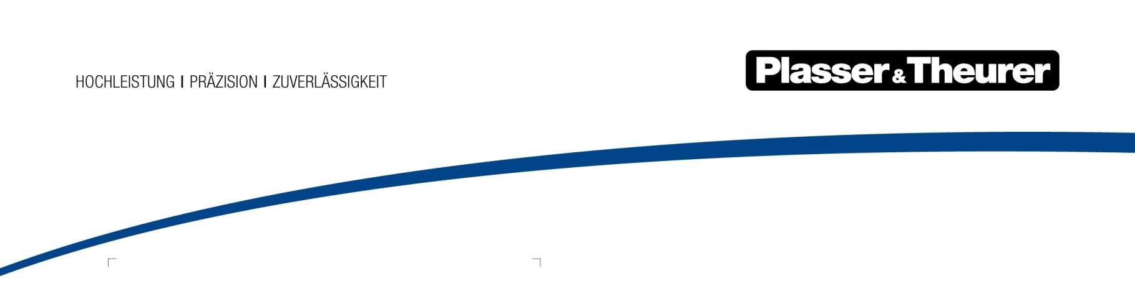

September 2022

Railway paradise Austria: a new green maintenance fleet for ÖBB
The largest single order in our company’s history: Plasser & Theurer will supply a highly modern fleet of maintenance vehicles to the infrastructure undertaking in the European Union’s most rail-friendly country. The ÖBB Infrastruktur fleet has entered a new era, and there are three pillars underlying it: a hybrid E³ drive concept for emission-free working on-site, improved ergonomic design, and modular design.
To ensure seamless rail services on new lines, ÖBB Infrastruktur is renewing its entire maintenance vehicle fleet. In addition to ensuring maintenance on new lines and complex tunnel sections, ÖBB Infrastruktur prioritises expanded functionality along with increased cost efficiency and sustainability. Plasser & Theurer came out on top in the EU-wide call for tenders. The company will supply 56 vehicles to ÖBB Infrastruktur, with a purchase option available for an additional 46. It is the largest single order in the almost 70-year history of Plasser & Theurer, and it is the dawn of a new era in railbound maintenance vehicles.
Modular standards, individual configurations
Thanks to ModularCustomizing, important processes that are part of production, approvals, and maintenance will be simplified and standardised. It provides ÖBB Infrastruktur with several more advantages in addition to maximum flexibility and being able to adapt machines to its needs.
For example, a standard carrier vehicle will be equipped with individual mounted structures (modules); this reduces the costs of spare parts and maintenance significantly.
Plasser & Theurer will supply three types of vehicles. ÖBB Infrastruktur will have a high- performance maintenance vehicle fleet, with three types of vehicles instead of 12, based on a uniform operating concept. This simplifies maintenance and reduces the costs of training and staff.
Hybrid drive with power from the overhead contact line, battery-operated for the worksite
Operating with power from the overhead contact line, the new drive concept enables fully electrified driving at speeds of up to 120 km/h. However, when there are disruptions or new structures, power from the overhead contact line may not be available.
That is why the vehicles are equipped with powerful batteries: they ensure power is available for maintenance of the entire network. It is possible to fall back on a diesel-electric power pack as a precaution against blackouts and in an emergency. E-fuel can be used to operate it in a carbon-neutral way. The highest flexibility is ensured through the option to switch between the overhead contact line, battery, and diesel-electric power pack without interruption.
Back in 2017, Plasser & Theurer presented the first battery-powered vehicle for overhead contact line installation and maintenance at the International Exhibition for Track Technology in Münster. Since then, more experience has been gained and the technology has been optimised: the battery used for worksite operation can supply enough energy for an entire shift. It is charged via the overhead contact line (pantograph), the diesel-electric power pack, or recuperation while driving.
Low emissions and reduced noise during operation protect the environment and make working conditions on and around the vehicle noticeably better. This is also a major advantage for lineside residents.
Plasser & Theurer’s E³ drive concept significantly reduces diesel consumption and CO₂ emissions.
Maximum customer benefits thanks to consistent, continuous development
In addition to regular assembly and maintenance work, the new vehicle fleet will be used for overhead contact lines, particularly when there are disturbances. Technical defects and storms are a real challenge for infrastructure managers. The ability to return operations to normal quickly and efficiently is crucial.
This consistent, continuous development is not only limited to the drive and the modular design system. A bogie with secondary suspension will be installed to increase comfort and stability while working. In addition, the vehicles will feature well-proven cranes and elevating work platforms with a high reach and powerful lifting capacity. This simplifies and optimises assembly and maintenance.
With the new green fleet, ÖBB Infrastruktur and Plasser & Theurer are taking a strong stance for the future: emission-free, efficient, and high-capacity operation of rail infrastructure.
Bild | Dateibezeichnung | Bildbeschreibung
 | Grüne Flotte für ÖBB.jpg | ÖBB’s new green fleet  56 high-performance vehicles for maintenance across the network
 | Plasser CatenaryCrafter 15.4 E3 Typ 1.jpg | Plasser CatenaryCrafter 15.4 E³ | Typ 1  Overhead contact line vehicle – optimised for use on new lines
 | Plasser CatenaryCrafter 15.4 E3 Typ 2.jpg | Plasser CatenaryCrafter 15.4 E³ | Typ 2  Overhead contact line vehicle – performs inspections and maintenance, remedies failures and natural disasters
 | Plasser MultiCrafter 15.4 E3 Typ 3.jpg | Plasser MultiCrafter 15.4 E³ | Typ 3  Multipurpose vehicle for track maintenance – maintaining tunnels, cutting back vegetation, and removing snow, ...
 | Energiefluss.jpg | Green E³ hybrid drive:  Energy from overhead contact line and batteries

Plasser & Theurer in brief
- Founded in 1953
- Around 2,000 staff members in Austria
- Around 5,000 staff members worldwide, at 19 partner firms throughout the world and in Austria
- Range of products: machines and systems for laying and installing, renewing, and maintaining tracks and overhead lines
- More than 17,000 heavy-duty machines supplied to 110 countries
- Export rate of 93 %
- Main factory in Linz, head office in Vienna
- Service, repair, and spare parts depots all over the world
- Largest sale markets overall: Germany, USA, UK, India, Japan, France, Austria, Brazil, Spain, Australia
- Customers: railway operators, construction firms, urban transport authorities, industrial and mine railways
- More than 2,000 active patents
- 14 international certificates/qualifications (such as ISO 9001:2015, ISO 14001:2015, ISO 37001:2016, ISO 37301:2021, ISO 45001:2018, ISO 50001:2018)

Contact:
Plasser & Theurer, Export von Bahnbaumaschinen Gesellschaft m. b. H.
1010 Wien, Johannesgasse 3
Phone: +43 1 51572-10122
Email: presse@plassertheurer.com
www.plassertheurer.com/presse

“Plasser & Theurer” and “Plasser” are internationally registered trademarks.

