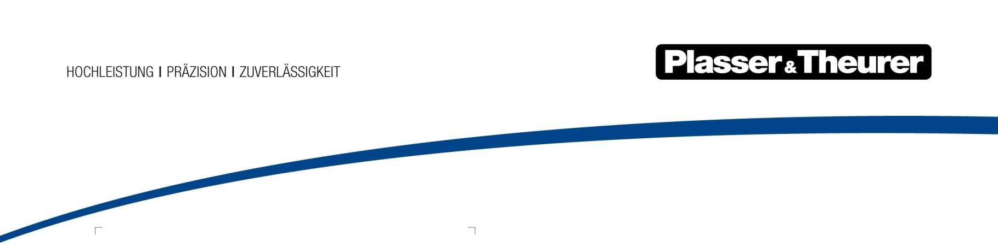

June 2022

Embracing the digital future with VolkerRail
31 May 2022 at the 28th International Exhibition for Track Technology (iaf) in Münster: the Dutch track maintenance contractor VolkerRail, a company of the VolkerWessels group, has signed a development partnership agreement for the Unimat 09-8x4/4S Dynamic E³ by Plasser & Theurer. It is a milestone for the global change process moving towards digitalised track maintenance: the beginning of a challenging and one-of-a-kind collaboration.
VolkerRail is one of the top track maintenance companies in Europe. With around 1,200 employees and a cutting-edge vehicle fleet, it builds new tracks and provides track maintenance services. The company is a highly sought out specialist for bridges, locks, and barriers. It has been counting on Plasser & Theurer machines since 1987. Five of them are currently in operation, with the Unimat 09-8x4/4S Dynamic E³ joining the fleet in 2024. As a machine showcasing new technology, it performs complete turnout and track maintenance in the technologically correct sequence. This includes everything from pre- and post-measuring work to tamping, sweeping, and track stabilisation with the DGS work unit.
This complete work concept is one of the main reasons why VolkerRail decided to acquire the machine. Another highlight is the hybrid drive system: for the first time, driving and working in the dual-voltage network in the Netherlands is possible. In view of the ambitious climate targets the Netherlands has, this is a clear competitive advantage.
A dynamic development partner
As a company which presents itself as completely open to technological innovations, VolkerRail is the ideal partner for a development partnership agreement. This is because the
Unimat 09-8x4/4S Dynamic E3 for VolkerRail will be equipped with the latest, most sophisticated digital solutions Plasser & Theurer is currently working on. These solutions will be tested and finalised during operations on Dutch tracks. VolkerRail has agreed to make the machine available for updates at specific intervals as well as to share experiences acquired during practical operation.
Future-proof digital equipment
The Plasser InfraScan measuring system is one of the digital systems on the Unimat 09-8x4/4S Dynamic E^{3.} It inspects track infrastructure and its environment. It collects data on the structure gauge, ballast distribution, positions of the track platform and contact wire as well as the distance to the adjacent track. As a result, it is possible to detect potential dangers early on and to make any necessary corrections immediately after operation. Plasser TampingControl will also be on board - it automatically checks ballast compaction, and the results are documented in the
Plasser TampingReport. Further, the machine has the Plasser ReferencedTrackGeometry fixed-point measuring system and the Plasser TampingAssistant turnout tamping assistance system.

New standards for operating staff
The machine will introduce a new cab concept in addition to its technical innovations. There will not be any work cab for turnout tamping. This workstation will be integrated into the continuously moving work cab. Freeing up this space makes the dimensions of the crew room larger: in the future, this is where all construction-site processes can be handled directly on the machine. As a company for whom social considerations are especially important, this feature played a notable role in VolkerRail’s decision to acquire the machine.
The Unimat 09-8x4/4S Dynamic E³ will be delivered to the Netherlands in the summer of 2024. In view of the innovative and sustainable equipment, all authorities involved will work on obtaining successful approval for the Dutch rail network at an early stage.

Image | File name | Caption
 | Abbildung1.jpg | Ben Hendriks (COO, VolkerRail), Nico van Zandwijk (Manager Safety, Plant & Equipment and Logistics, VolkerRail), Johannes Max-Theurer (CEO, Plasser & Theurer)
 | Abbildung2.jpg | The Unimat 09-8x4/4S Dynamic E³ for VolkerRail is equipped with the latest digital innovations.

Contact:
Plasser & Theurer, Export von Bahnbaumaschinen Gesellschaft m. b. H.
1010 Wien, Johannesgasse 3
Phone: +43 1 51572-10122
Email: presse@plassertheurer.com
www.plassertheurer.com/presse

“Plasser & Theurer” and “Plasser” are internationally registered trademarks.

