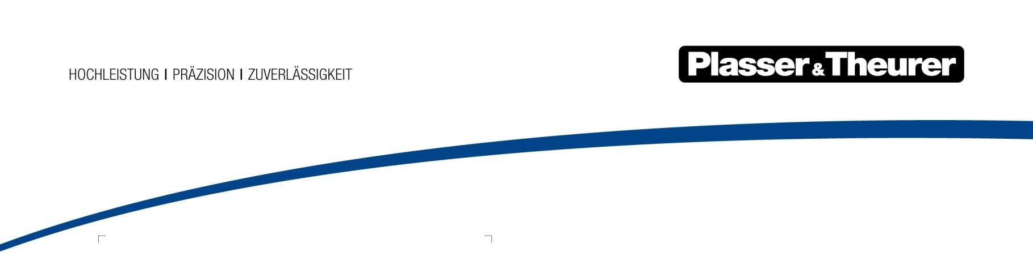

March 2022

The future of track maintenance is here
For the first time after a five-year hiatus, the largest trade fair for track technology, iaf, will take place in Münster in May 2022. Right on time and in line with the slogan “future track technology – NOW”, the Austrian technology leader Plasser & Theurer presents several new solutions tailored to meet current market needs. Technologies which facilitate an even more efficient use of existing capacities are central to these solutions.
Plasser & Theurer has been synonymous with technological progress in track maintenance for seventy years. Time and time again, the company has introduced machines to the market which make track maintenance work even more efficient, fast, and cost-effective. Particularly over the past years, a clear focus has been placed on expanding the machine, fleet, and infrastructure product portfolio. Digital technologies form the basis of essential innovations that promote greater automation of work processes. The latest machine generation clearly reflects this trend.
Handling limited staff resources effectively
As in many industries, a lack of qualified staff is also a major issue in track maintenance. This makes it even more important to find solutions to automate track maintenance even more. The new Unimat 09-8x4/4S BR Dynamic E³ maintenance system by Plasser & Theurer shows how this is possible using state-of-the art technology. It was developed specifically for maintaining high-capacity turnouts. Short track possessions make it necessary to maintain them in an extremely fast, precise, and efficient way. Integrated ballast management is an essential prerequisite, as precise ballasting is part of the process.
The new machine sets itself apart with a spacious and comfortable crew compartment. It is clearly a perk in view of this extremely challenging job. What also stands out is that there is only one operator’s cab for two operators on the machine’s main frame. With digitalised systems supporting work processes, staff reduction has become an option. What is currently being tested as a field study is expected to offer many operating companies a new way to deal with staff shortages.
A new offer for ballast regulation
Achieving high quality in a short amount of time: that’s the goal for track maintenance companies, also as regards ballast distribution and profiling. Once again, a new Plasser & Theurer technology allows for greater flexibility. The ballast distributing and profiling machine is the first machine to feature a sweeping unit suitable for both concrete and wooden sleepers. This eliminates the time and effort needed to reconfigure the machine. For switching from working on one kind of sleeper to another, adjusting the sweeping unit settings is the only necessary step.
In line with ModularCustomizing, the new ballast regulating machine can be tailored even more closely to individual customer requirements. Plasser & Theurer’s new ballast regulating simulator is a tool that makes training even more flexible and mobile, and it makes switching to the new machine even easier.
Handling rail welding more easily
For years, Plasser & Theurer’s APT 1500 mobile rail welding robot has been the only flash-butt welding technology that was also approved for transport by lorry without a special permit. The new welding unit is now in its final stage of development. The new design focuses on the fundamental features: the welding head is approx. 35 % lighter and the sensor system has been reduced to the essential elements. This greatly simplifies operating and maintaining the system. The new welding unit will continue the success of the APT series: until now, the first APT 1500 R has joined nearly 20,000 rails. As its performance and quality are consistently excellent, one customer even invested in a second APT 1500 R in 2020.
Retrofits for all machine lengths
Plasser & Theurer is ringing in a new age of track maintenance. Along with machines and technologies, the strategic expansion of Customer Services is at the top of the agenda. In July of this year, the new European Distribution Center will open in Linz. It will allow us to secure the original spare part supply chain for our customers. In terms of services, Used Machines stands out as a newly introduced segment. This service will allow customers to purchase used Plasser & Theurer track maintenance machines directly from the manufacturer.
Retrofitting, i.e. the refurbishment and modernisation of older machines, is also one of the fast-growing segments at Plasser & Theurer's Customer Services. Together with the partner network, machines of different shapes and sizes are refurbished and essential features are brought up to the state of the art. The time-tested SSP 110 SW ballast regulating machine is only one example. For tamping machines, such as the Unimat 08-475/4S, this offer comprises an upgrade to the latest tamping technology with a sustainable electric drive. A machine length of 114 m is not an issue: a track relaying train of this length is currently being refurbished in Linz.
Machine, fleet, and infrastructure remain at the top of the agenda
Providing technologies that respond exactly to customer needs is the main goal in the year of the largest international trade fair for track technology. In addition, the Austrian technology leader remains true to its objectives in the machine, fleet, and infrastructure segments. In the machine segment, ModularCustomizing is a new offer that provides an individualised fleet with high standards. In the fleet segment, the focus remains on services over the entire machine life cycle. In terms of infrastructure, digital solutions for maintaining railway infrastructure and complementary services continue to be the main topics of interest. Another test vehicle of the EM-VT series is being launched. On board: the latest measuring technology for testing new technologies in practice and for expanding the range of services for infrastructure companies.
All in all, Plasser & Theurer continues to expand its range of technologies and services with the clear goal of using innovation to promote the railway’s position as the most eco-friendly transport system. Enhancing the capacity of this transport system is becoming increasingly important for the sustainable thinking for tomorrow. Plasser & Theurer is prepared to meet its requirements.

image | File name | Caption
 | Abbildung1.jpg | The new Unimat 09-8x4/4S BR Dynamic E³ maintenance system by Plasser & Theurer shows how this is possible using state-of-the art technology. It was developed specifically for maintaining high-capacity turnouts.
 | Abbildung2.jpg | The ballast distributing and profiling machine is the first machine to feature a sweeping unit suitable for both concrete and wooden sleepers.
 | Abbildung3.jpg | The new welding unit will continue the success of the APT series.

Plasser & Theurer in brief
- Founded in 1953
- Around 2,000 staff members in Austria
- Around 5,000 staff members worldwide, at 19 partner firms throughout the world and in Austria
- Range of products: machines and systems for laying and installing, renewing, and maintaining tracks and overhead lines
- More than 17,000 heavy-duty machines supplied to 110 countries
- Export rate of 93 %
- Main factory in Linz, head office in Vienna
- Service, repair, and spare parts depots all over the world
- Largest sale markets overall: Germany, USA, UK, India, Japan, France, Austria, Brazil, Spain, Australia
- Customers: railway operators, construction firms, urban transport authorities, industrial and mine railways
- More than 2,000 active patents
- 14 international certificates/qualifications (such as ISO 9001:2015, ISO 14001:2015, ISO 37001:2016, ISO 37301:2021, ISO 45001:2018, ISO 50001:2018)

Contact:
Plasser & Theurer, Export von Bahnbaumaschinen Gesellschaft m. b. H.
1010 Wien, Johannesgasse 3
Phone: +43 1 51572-10122
Email: presse@plassertheurer.com
www.plassertheurer.com/presse

“Plasser & Theurer” and “Plasser” are internationally registered trademarks.

