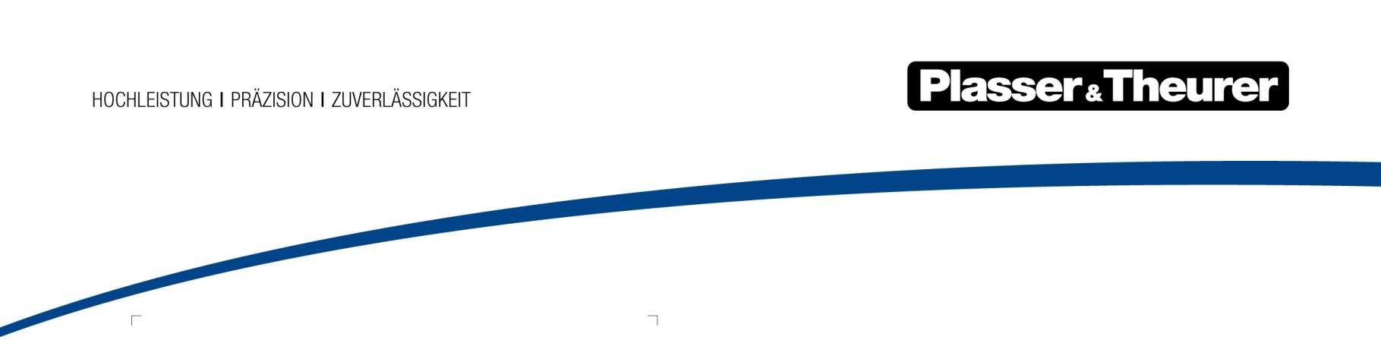

5 January 2022

Change at the executive management level of Plasser & Theurer
Daniel Siedl left the company at the end of 2021. As of 1 January 2022, Stefan Peiker
is the new COO of Plasser & Theurer, Export von Bahnbaumaschinen,
Gesellschaft m.b.H.
Daniel Siedl would like to pursue a different career path, which is why he ended his contract. Stefan Peiker has assumed his duties and responsibilities.
Dr. Stefan Peiker, COO (Chief Operating Officer – Production)
After studying mechanical engineering, he acquired 32 years of experience in various managerial positions at MAN Truck & Bus. Mr. Peiker joined Plasser & Theurer as a consultant and became the Director of Plant Management mid-August 2019.

In the words of CEO and owner Johannes Max-Theurer, “I am sad to see Mr. Siedl leave, both on a professional and personal level. I wish him all the best for his future endeavours. At the same time, I am happy to have Stefan Peiker in charge of Production as the new COO. I wish him all the best for his future tasks.”

Image | File name | Caption
 | Stefan Peiker.jpg | Dr. Stefan Peiker, COO (Chief Operating Officer – Production)

