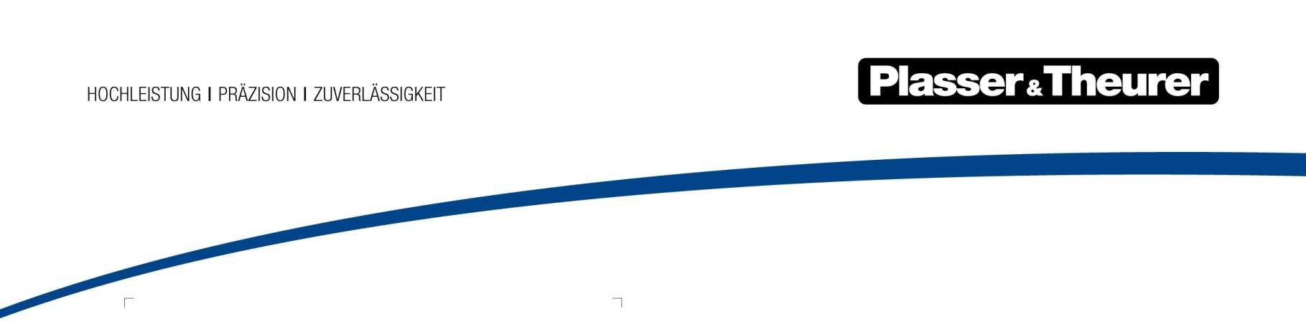

June 2021

Humanitarian aid: five companies take part in project initiated by Plasser & Theurer and Plasser India

Oxygen for India
India was hit by the pandemic. We are seeing shocking images in the media. People are dying because the oxygen supply in hospitals is insufficient.

To Plasser & Theurer, it is important to provide quick and unbureaucratic help. We took action together with four other companies. Westfalen AG donated 400 bottles of oxygen. Qatar Airways and cargo-partner shipped them to India. Plasser India, a Plasser & Theurer partner company, is in charge of safely delivering the life-saving gas to a hospital in New Delhi. As initiator,
Plasser & Theurer is overseeing the entire project.

Siegfried Fink, Managing Director of Plasser India: “Helping quickly and efficiently is very important to us. I want to thank everyone who is involved in this project, helping to save lives”.

“We hope that the situation in India will improve soon. We are happy to have made a small contribution by delivering 400 bottles of oxygen,” says Johannes Max-Theurer, CEO of
Plasser & Theurer.

“All the companies involved have put their heart, soul and know-know into making our initiative a success”, says Henning Kordts, manager in charge of bottling technical gases at Westfalen Group. “We hope it helps to alleviate the acute need in India.”

Image | File name | Caption
 | PA Sauerstoff für Indien1a.jpg | 400 bottles of medical oxygen were prepared for  shipping in Linz
 | PA Sauerstoff für Indien2.jpg
 | PA Sauerstoff für Indien2a.jpg | Plasser India, a Plasser & Theurer partner company,  is in charge of safely delivering the oxygen to a  hospital in New Delhi.
 | PA Sauerstoff für Indien2b.jpg

About Plasser & Theurer:

The Austrian family business Plasser & Theurer stands for cost-efficiency and innovation in track construction and maintenance. Employing approximately 1,900 members of staff, the company has supplied around 16,700 machines to 109 countries since 1953. More than half of them are still in operation today. Most of the machines are manufactured in the main factory in Linz. The machine portfolio covers almost all work to be performed when maintaining, laying, and renewing railway tracks. It ranges from simple tamping machines to 200 m long high-capacity machines. As a full-range supplier collaborating with 19 partner companies around the world, Plasser & Theurer offers comprehensive customer services. They include training, spare parts supply, and technical service. Plasser & Theurer has been revolutionising track maintenance technology for decades. The company also emphasises its aim to offer railway systems substantial support in the digitalisation of infrastructure.

