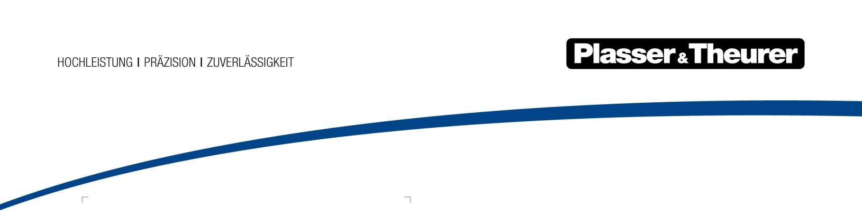

Machine – Fleet – Infrastructure:

a new product portfolio
Plasser & Theurer’s aim is to ensure economic benefits for our customers. We will continue along this path in the future, breaking new ground in line with the strategy “Machine – Fleet – Infrastructure”. Topics such as sustainability, digitalisation, and modern customer services are of crucial importance in this context.
Plasser & Theurer has been revolutionising track maintenance technology for decades. To ensure long-term success, our company recognises the market’s needs and provides the right answers quickly.
MACHINE: configuration options for individual needs
Customers who would like more efficient maintenance and spare parts management for their fleets as well as more efficient training and homologation will be able to rely on machines that are part of the “ModularCustomizing” product line. Despite increasing standardisation, in this category Plasser & Theurer still remains true to the principle of meeting specific requirements as best as possible. Here’s the perfect example: right now, high-capacity tamping machines can be built in more than 100 different configurations.
Customers who have very specific needs regarding functionality and design can take advantage of the customised machines in the “Individual Design” product line. A typical example is the high-capacity RUS 1000. Not only does this machine replace sleepers, rail fastenings, and rails during a single track possession, it also cleans the ballast bed.
FLEET: customer services over the entire life cycle of the machines
Depending on their size, location, and corporate philosophy, companies in our sector will have very different requirements in terms of customer services. Services with specific economic benefits will gain ground. It is for this reason that we have restructured our portfolio in this area. We have expanded it to include new services. With retrofits, we modernise machines that are 20 or 30 years old. This extends their service life by approximately ten years and increases their performance. Our new service packages include four different servicing categories and are available for individual machines and entire fleets.
INFRASTRUCTURE: the smart digitalisation of railways
We see digitalisation as an opportunity to enhance the benefits of our machines and customer services. The turnout tamping assistance system “PlasserSmartTamping – The Assistant” helps operators to manage the machine’s operating systems.
At the same time, Plasser & Theurer is developing digital tools that record the track in full. The EM100VT track recording car serves as a development platform: its measuring runs are twenty times faster than those performed with more dated methods. The data it records flows into modern Building Information Modeling (BIM). BIM speeds up structural planning, construction, and administration. It also decreases susceptibility to faults, makes costs more transparent, and promotes cooperation between all project stakeholders. In this product segment, we offer infrastructure operators and construction companies complementary services. For example, they can use the URM 700-2: until now the only turnout cleaning machine.
Plasser & Theurer emphasises its aim to offer railway systems substantial support in the digitalisation of infrastructure and is developing technologies to make railway infrastructure operation even more sustainable.

Plasser & Theurer in brief
- Founded in 1953
- Around 2,200 members of staff in Austria
- Around 6,000 members of staff worldwide, at 22 partner firms throughout the world and in Austria
- Range of products: machines and systems for laying and installing, renewing and maintaining tracks and overhead lines
- More than 17,400 heavy-duty machines supplied to 110 countries
- Export rate of 93 %
- Main factory in Linz
- Head office in Vienna
- Service, repair, and spare parts depots all over the world
- Largest sale markets overall: Germany, USA, Great Britain, India, Japan, France, Austria, Brazil, Spain, Australia
- Customers: railway operators, construction firms, urban transport authorities, industrial and mine railways
- More than 2,500 active patents
- 12 international certificates/qualifications (such as ISO 9001, ISO 14001 and ISO 50001)

Contact:
Plasser & Theurer
Export von Bahnbaumaschinen Gesellschaft m. b. H.
1010 Wien, Johannesgasse 3
Phone: +43 1 51572-0
Fax: +43 1 5131801
Email: presse@plassertheurer.com
www.plassertheurer.com

“Plasser & Theurer” and “Plasser” are internationally registered trademarks.

