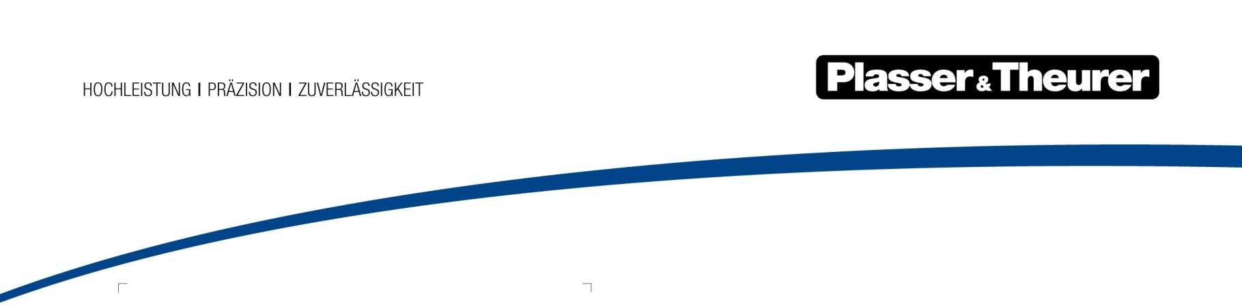

July 2019

Track laying for India’s largest railway construction project
Produced at Plasser India, three SVM 1000 I track laying trains are working on the largest infrastructure project in India. The impressive construction projects include a dedicated freight corridor with a total length of around 3,300 km.
As there is a lack of capacity for the transport of raw materials and industrial products, India has been investing heavily in the expansion of the rail network for many years. “Dedicated Freight Corridors” are created which, as the name says, are dedicated specifically to freight transport.

Indian contractors are working with Plasser & Theurer machines
In the West corridor alone, the project consists of laying about 1,400 km of track, installing numerous turnouts, building more than 1,300 bridges and 20 stations as well as supplying the required equipment. Such construction projects require the latest technologies and state-of-the-art methods of international railway construction. The construction tasks are placed in lots, with all the large Indian construction companies being involved, such as IRCON, Tata, L&T Larsen & Toubro and GMR Group. All companies rely on the efficiency and quality of Plasser & Theurer machines and work with different machine types on these construction sites.

GMR starts with a modern machine fleet
GMR Group is involved in the construction of the Eastern corridor. The company uses two continuous action SVM 1000 I track laying machines, which were purchased in the last two years. In addition, GMR uses two Duomatic 08-32 C track tamping machines, one Unimat 08-275 3S universal tamping machine, two PBR 400 ballast profiling machines with integrated turntable and one DGS 62 N Dynamic Track Stabiliser for the associated construction tasks.

Assembly line track laying using the SVM 1000 I
The SVM 1000 I has been designed for laying new track in particular. The first machine of the SVM series was put into operation in Australia in 1981. Since then, it has since laid thousands of kilometres of track. Operated highly successfully on four continents, the proven machine concept stands out due to its compact design, ease of use, precise sleeper placement and the high output. Experience has shown that - with a continuous supply of new sleepers and rails - an output of 300 km per year can be expected.

The SVM 1000 I, consisting of one laying unit and two portal units, is built by Plasser India. The machines are equipped with clip units. They are suitable for the transport and laying of sleepers and rails. The portal units are height adjustable allowing compliance with the gauge during transfer travel. For this, the craneway is lowered into the parking position.

The construction train is supplemented with flat cars, 45 of them in the case of GMR Group. These have been adapted for the transport of the sleepers and rails required for track construction. One layer of UIC 60 rails (12 rails of 250 m length) sits below four layers of concrete sleepers of Indian manufacture. As a rule, 24 such cars are coupled to the laying machine with sufficient material for 1.5 km of track, which corresponds approximately to the output of a 6-hour work shift.

New track construction with integral rail placement
Portal units equipped with special gripper arms pull the rails to the front of the machine. Hydraulically adjustable role ensure the correct guidance. At the front, the rails are taken over by a site vehicle with rail grippers and pulled onto the ballast bed over auxiliary rollers. This is how the rails are pre-positioned in defined construction stages.

During work operation, the laying machine is supported on the front transport car. The track-laying truck is used as the drive for the complete train, including the sleeper and rail transport cars. The portal units transport each layer of sleepers to the laying unit. A proven feed system takes them to the laying unit, which lays them at a precise spacing. The laying output achieved during use in India is ten to twelve sleepers per minute. The pre-positioned rails are lifted again, taken past the machine frame, placed on the newly laid sleepers and fixed using the integrated clip units. The complete material logistics therefore takes place on the track under construction.

The basic machine concept includes an autonomous energy supply. Once operation has started, the SVM 1000 I works continuously. A reference wire serves to guide the machine for accurate laying of the sleepers with regard to lateral alignment and radius.

To complete the track construction work, a Plasser & Theurer MDZ mechanised track maintenance train is available, consisting of a levelling, lifting, lining and tamping machine, a ballast profiling machine and a Dynamic Track Stabiliser.

Larsen & Toubro uses Plasser & Theurer technology
L&T Larsen & Toubro, India’s largest construction company, is mainly active in the construction of roads, industrial plants, airports, urban development, but also in metro systems. Now, L&T carries out its first large construction project on a standard gauge railway in the West corridor, using one SVM 1000 I track laying machine and the machines for track maintenance (Unimat 08-275 3S, Duomatic 08-32 C, PBR 400, DGS 62).

10,000 km for more freight traffic capacity
In the final phase, a network of dedicated freight corridors will cover India, connecting the country’s four largest metropolises: Delhi, Mumbai, Chennai and Kolkata Together with the two diagonals - North-South Corridor (Delhi-Chennai) and the East-West Corridor (Kolkata-Mumbai) - the Golden Quadrilateral Freight Corridor (GQFC) will be created. In future, it will transport 55% of the freight traffic of the Indian Railways on a total length of about 10,000 km.

Image |  | copy
 | Indien SVM 1000 I Bild 1.jpg | The SVM 1000 I is consisting of one laying unit and two portal units.
 | Indien SVM 1000 I Bild 2.jpg | The pre-positioned rails are lifted again, taken past the machine frame and placed on the newly laid sleepers.

