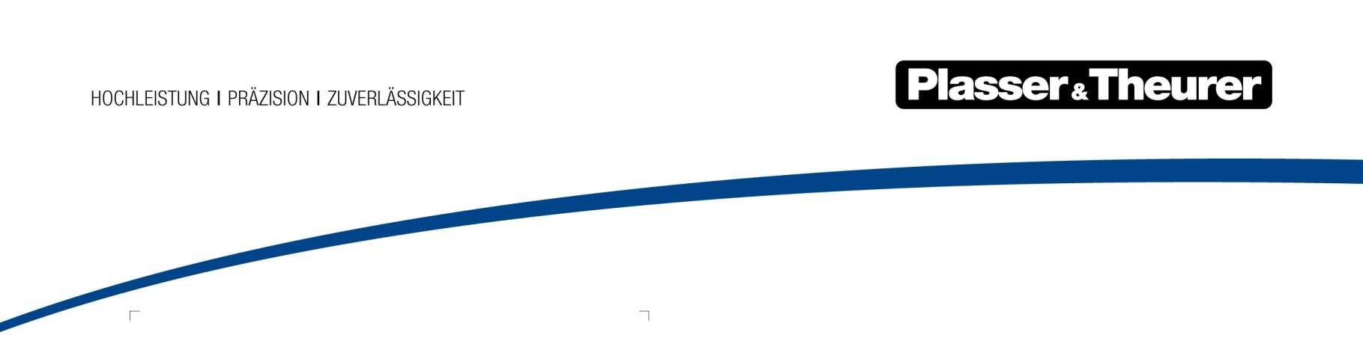

20 September 2018

Plasser & Theurer receives Supplier of the Year award from Deutsche Bahn
In a ceremony at “InnoTrans”, the International Trade Fair for Transport Technology in Berlin, Plasser & Theurer was presented with the DB Supplier Award in the “Rail Vehicles and Rail Vehicle Components” category.
With an annual purchasing volume of over 20 billion euros, DB is one of Germany’s largest contracting bodies and has business relations with over 30,000 companies worldwide. Every two years the company prize is awarded in four categories. In 2018, Deutsche Bahn AG added a new award, the Supplier Innovation Award for outstanding innovation performance.
Plasser & Theurer received its award in the “Rail Vehicles and Rail Vehicle Components” category for its modular vehicle platform MISS which sets innovative and technological standards. MISS stands for Track Infrastructure Multifunctional Maintenance Vehicles. These vehicles enable the flexible implementation of varying requirements in the upgrade and repair of track infrastructure, e.g. in construction, inspection and maintenance contracts. Their core tasks include the replacement of sleepers or closure rails following a rail break, or the replacement of whole switch frog points and switch blades. The newly developed machines are considerably more powerful and flexible than previous models which are now being gradually replaced throughout Germany. In spring 2018 the first of 28 latest generation track working vehicles was handed over to DB Netz AG.
The Austrian family business Plasser & Theurer stands for cost-efficiency and innovation in track construction and maintenance. With the recent introduction of the first fully electric tamping machine Plasser & Theurer has demonstrated, once again, its position as a global leader in the technology of track construction machines.
This year, Plasser & Theurer was the only company to be nominated for a second award by DB, the Supplier Innovation Award. In particular, this award recognises new developments which have a high degree of innovation, add value, can easily be implemented or are highly sustainable.
As a long-standing reliable partner and supplier of DB, Plasser & Theurer identifies especially with the objectives and the 2020+ strategy of Deutsche Bahn AG. “We are proud to have received this award from Deutsche Bahn, as it is an important sign of trust in our work as a supplier and partner for the railway system”, said Johannes Max-Theurer, Managing Director of Plasser & Theurer.
Image captions
Image | File name | Image description
DB Supplier Award presented to
Plasser & Theurer at InnoTrans
on 18 September 2018.
©Deutsche Bahn AG, Kai Michael Neuhold

