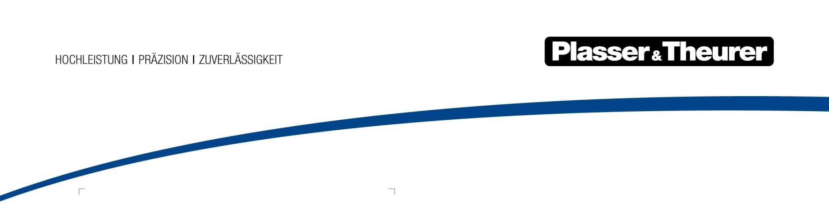

April 2024

31 inventions registered in 2023 – Plasser & Theurer continues to focus on innovation
Since the company was founded over 70 years ago, Plasser & Theurer has been developing track maintenance technologies for the future. Over 10,000 patents have been registered since 1953, of which more than 2,500 are still valid. The figures recently published in the annual report of the Austrian Patent Office are impressive proof that the company continues to follow its guiding principle and focus on innovation: in 2023, the technology leader placed third in Austria’s national ranking.
In 2023, a total of 2,242 inventions were registered with the Austrian Patent Office, a slight increase compared to the previous year. With 31 patent and utility model applications, Plasser & Theurer, a driving force for technological progress in track maintenance for decades, ranks third in Austria. As in previous years, this makes the Austrian family-owned company one of the largest domestic patent applicants and underlines its claim to decisively support the railway system with innovations and make it future-proof, even in challenging times.

Bild | Dateibezeichnung | Bildbeschreibung
 | Unimat 09-4x4/4S E³.jpg | As a digital assistant, the Plasser TampingAssistant ensures high tamping quality and process reliability.

Plasser & Theurer in brief
- Founded in 1953
- Around 2,200 staff members in Austria
- Around 6,000 staff members at 22 partner companies throughout the world and in Austria
- Range of products: machines and systems for laying and installing, renewing, and maintaining tracks and overhead contact lines
- More than 17,700 heavy-duty machines supplied to 110 countries
- Export rate of 93%
- Main factory in Linz, head office in Vienna
- Service, repair, and spare parts depots all over the world
- Largest sales markets overall: Germany, USA, UK, India, Japan, France, Austria, Brazil, Spain, Australia
- Customers: railway operators, construction companies, urban transport authorities, industrial and mine railways
- More than 2,500 active patents
- 14 international certificates/qualifications (such as ISO 9001:2015, ISO 14001:2015, ISO 37001:2016, ISO 37301:2021, ISO 45001:2018, ISO 50001:2018)

Contact:
Plasser & Theurer, Export von Bahnbaumaschinen Gesellschaft m. b. H.
1010 Vienna, Johannesgasse 3
Tel.: +43 1 515720
Fax: +43 1 5131801
Email: presse@plassertheurer.com
https://www.plassertheurer.com/en/company/press
“Plasser & Theurer” and “Plasser” are internationally registered trademarks.

