Pressrelease
Green fleet for the most modern maintenance
- ÖBB-Infrastruktur AG invests 250 million in environmentally friendly Plasser & Theurer vehicles
- High-tech hybrids replace diesel maintenance vehicles
- Success story: 100% Austrian added value thanks to the collaboration between two of the country’s top companies

ÖBB-Infrastruktur AG’s future-proof renewal of its maintenance fleet continues to pick up pace. As part of an event on 1 June 2023, ÖBB and Plasser & Theurer presented the first of 56 new high-performance maintenance vehicles: a Plasser CatenaryCrafter 15.4 E³.
A new era of sustainability in network maintenance: The new CatenaryCrafters and MultiCrafters are replacing the maintenance vehicle fleet which ÖBB has been operating for decades. The predecessor fleet was also manufactured by Plasser & Theurer. After 40 years of reliable service, it can finally be retired. ÖBB-Infrastruktur AG awarded the company the contract for 56 emission-free high-performance maintenance vehicles (21 Plasser MultiCrafters for permanent way; 29 Plasser CatenaryCrafters for the overhead contact line, maintenance, and assembly; and six Plasser TransportUnits) worth almost €250 million. A purchase option is available for an additional 46 vehicles. The E³ drive technology, which enables an environmentally friendly electric hybrid drive, convinced them. A completely newly developed modular design is based on a standard carrier vehicle, engineered in three versions according to the specific task.
The green drive system for the future
With energy supplied by electricity from the overhead contact line and a battery, the new drive system is eco-friendly. This ensures ÖBB is able to meet its high standards in terms of sustainability. In addition, the modular design optimizes the fleet’s availability. Individual assemblies are completely pre-mounted and have already been checked. They can be quickly exchanged as needed. This reduces vehicle downtimes due to servicing. Furthermore, emission-free work on every site is possible thanks to the innovative drive concept featured in the new, ultramodern fleet.
As emphasized by Johannes Max-Theurer, CEO of Plasser & Theurer: “For us, the new ÖBB fleet is the largest single order in Plasser & Theurer’s 70-year company history. We are especially happy about the decision to equip all the vehicles with our E³ technology because that way we can continue to bolster the most sustainable transport system – the railway.”

A wide range of applications for uninterrupted operations
Judith Engel, a member of the ÖBB-Infrastruktur AG board of management, on the vehicles’ range of applications: “For us, the machines are an essential tool for maintaining overhead contact lines, permanent way, and superstructure. They also play an important role in building new overhead contact lines, for inspections, or for intervening quickly if there is a disruption. The new fleet is powered by electricity instead of diesel; the modular design offers flexibility and noticeably increases availability. That helps our rail network both in terms of cost-effectiveness and quality.”
Distributed throughout Austria, this ensures quick availability as needed in a given region. Machines of this type are the first on-site, allowing lines to be quickly reopened for traffic. They are also deployed to keep permanent way and the structure gauge clear. To that end, the vehicles are equipped with a large selection of tools, also for snow removal. Another addition is the ETCS equipment for modern train protection, as Austria is planning to implement the system across the country.

First vehicle in the ÖBB network
The first vehicle in the series, a Plasser CatenaryCrafter 15.4 E³, is being tested exhaustively on Austrian rails. It is undergoing all the necessary approval processes in order to be deployed for regular operations as soon as possible. It features a railway crane with a wide operating range, ensuring a safe position and a protected working environment for staff, also in highly exposed areas. Thanks to the three-part elevating work platform in the centre of the machine, it is possible to work on three different positions simultaneously. This has a positive effect on ergonomics and work performance. An integrated crew area and a workshop also ensure that staff do not have to leave the safety of the vehicle. The CatenaryCrafter has space for up to 11 people, keeping them protected in running mode.

A machine fleet fit for the future
The new emission-free high-performance fleet is impressive proof: ÖBB and Plasser & Theurer know how to develop and modernize the provision of efficient, sustainable rail infrastructure.

Image | File Name | Caption
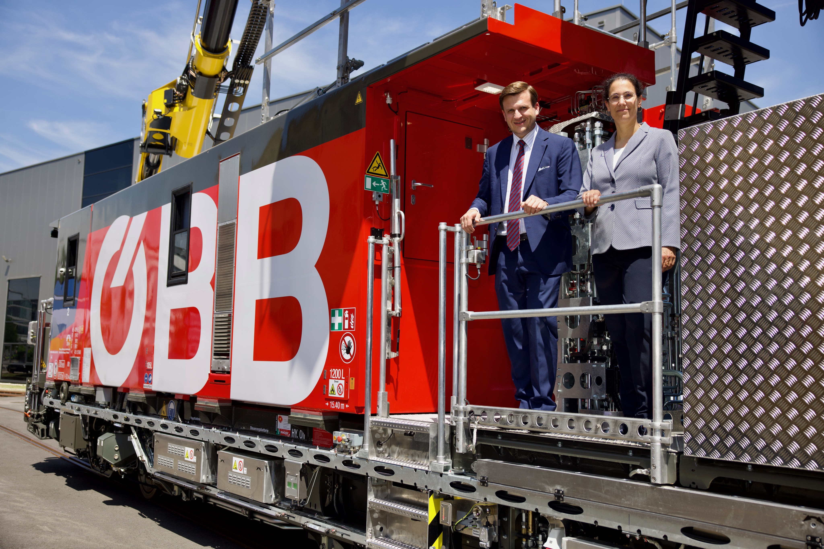 | ÖBB-Presentation CatenaryCrafter Linz.jpg © ÖBB/Andreas Scheiblecker | Linz, 1 June 2023: Judith Engel (member of the ÖBB-Infrastruktur AG board of management) and Johannes Max-Theurer (CEO Plasser & Theurer) present the new Plasser CatenaryCrafter 15.4 E³.

