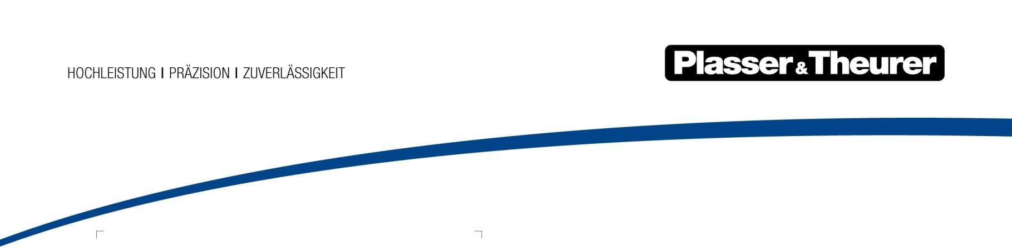

August 2020

Full turnout service
Plasser & Theurer stands for global expertise in track construction and maintenance. For decades, it has developed innovative technologies and have successfully applied them on track. To present these technologies to the expert community and introduce them to the market, solid information and client references are essential.

The URM 700-2 universal ballast cleaning machine is the new multitalent for ballast bed cleaning. Unique on the world market, its innovative technology enables Plasser & Theurer to fill a market niche by offering full turnout service.

Most contracting companies do not offer special services such as an on-track turnout maintenance system. Plasser & Theurer has taken full turnout service to a new level. Austrian Federal Railways (ÖBB) has been able to use this technology.

New offer for ballast cleaning in turnouts
Turnouts place particular demands on maintenance. Due to their key function in the track system, they are considered essential infrastructure components. Turnout installations on modern high-capacity lines consist of concrete sleepers, sensitive drive and control systems and heavy rail profiles. When maintaining turnouts, these expensive components must be handled with utmost precision. Cost-efficiency is the goal - not only when maintaining plain line track, but even more so when maintaining turnouts which often affects two tracks at the same time. The duration of track closures is a key factor, particularly for main-line railways.

The URM 700-2 offers decisive advantages when managing tight schedules for turnout maintenance. There is no need to remove and reinstall the turnout. Both ballast cleaning and tamping in turnouts can be completed during one single shift. As soon as the work has been completed, the track section can be reopened for traffic. For this reason, the Austrian Federal Railways have opted for employing this system on their priority routes. During maintenance with the URM 700-2, the adjacent track remains open for traffic which reduces track possessions to a minimum. This is impossible when employing conventional methods involving excavators and cranes.

Continuous-action turnout cleaning
Our URM 700-2 ballast cleaning machine is the core technology for turnout maintenance. This machine makes it possible to clean the ballast bed without removing the turnout. Moreover, it allows for continuous working progress. In addition, it cleans the ballast shoulders. The machine is also suited for maintaining large high-speed turnouts with movable-point frog. Another advantage is that sections of track at connecting tracks and between turnouts can be cleaned in one pass.

Thanks to the fast and independent installation and removal of the excavating unit, the URM 700-2 works cost-efficiently on short sections of track.

• Short set-up times
• No need to cut the rails, neither at the start nor at the end of work.
• No full track closures - the time required for ballast cleaning in turnouts is reduced significantly.

This is exactly what railway administrations require: fast, safe and high-quality ballast cleaning in turnouts without long track possessions.

Optimal results for many trains to come
After the URM 700-2 has completed its work, our all-rounder for track maintenance enters the picture to ensure optimal geometrical quality of the turnouts. The Unimat 09475/4S N-Dynamic turnout and track maintenance machine combines the functions of three machines: 3-rail lifting and 4-rail tamping, profiling, stabilising and control measuring. A unique feature makes the Unimat 09-475/4S N-Dynamic stand out: it can also ballast the tamping zones. Full turnout service including the ballasting step can be performed within a single track possession. Traffic on the adjacent track continues without interruption which minimises operational hindrances.

INFRASTRUCTURE OFFER BY FRANZ PLASSER: Complete turnout service

Our offer expands the range of products and services of infrastructure operators and construction companies. We translate our expertise and our technologies into diverse offers which create the basis for new partnerships. The use of innovative and specialised technologies is an economical alternative to machine purchases.

> Measurements and analyses
> Ground penetrating radar/ballast testing
> Ballast cleaning and renewal with the URM 700-2
> Restores track geometry (tamping, stabilising, etc.)
> If required, this includes exchanging/renewing all electronic components
> Eco-friendly disposal of excavated material

Calculated risk that speaks for itself:

• No fixed assets for investments
Users do not have to invest in niche technology and expertise; this saves budget funds.
• Professional results management and risk transfer
Our complete turnout service lets users focus on their core activities and enables them to outsource work to specialists.
• Complete service
One partner offers every product and service: a single point of contact saves time and staff costs.

This offer is made by Franz Plasser Vermietung von Bahnbaumaschinen Gesellschaft m.b.H.

Bild | Dateibezeichnung | Bildbeschreibung
 | Abb 1.jpg | The URM 700-2 maintaining two turnouts (EW1200) including a 300 m section of track on the western main line - cross-over point Linz-Jetzing.
 | Abb 2.jpg | The turnout can be maintained in one single pass: after removing the shoulders, ballast is removed from under the sleepers over a variable width.
 | Abb 3.jpg | The URM 700-2 on the western main line - cross-over point Linz-Jetzing.

