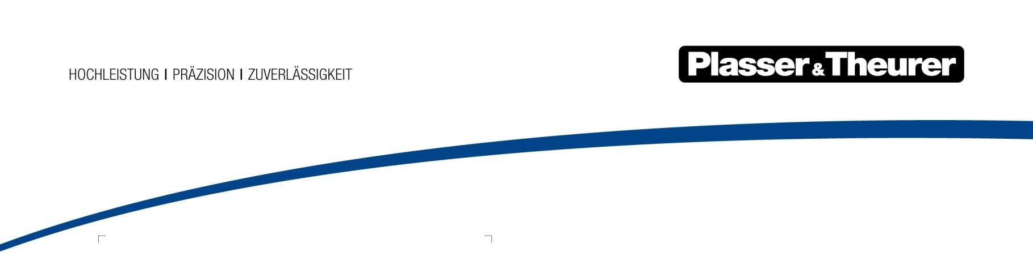

October 2019

Africa’s fastest line

The Maghreb kingdom of Morocco is making rapid progress with the construction of its high-speed network, just like its role model, the French TGV. The target is completion of a route network of 1,500 km by 2035.

Two main lines are planned – an “Atlantic line” of about 900 km length (Tangier-Rabat-Casablanca-Marrakesh-Agadir) and a “Maghreb line” of about 600 km length (Rabat–Meknès–Fès–Oujda).

Atlantic line to export port
The new Tangier-Kenitra line has the purpose of relieving the existing winding lines between Casablanca/Rabat and Tangier which are heavily utilised. The high-speed “Al Boraq” train – a name given to it by the Moroccan king – reaches a commercial speed of about 320 km/h between Tangier and Kenitra; a top speed of 357 km/h was measured during test runs.
A third track will be added to the existing double-track line from Kenitra to Casablanca by 2020. As soon as this can be used over its complete length, the existing tracks will be replaced so that the top speed can be increased to 220 km/h. This will reduce the journey time between the two economic centres of Casablanca and Tangier, which are 350 km apart, from originally about five hours to just over two hours on “Africa’s fastest line”, as it is also known.

New machines for track maintenance
For the economic and very precise maintenance required for the high speeds, the Moroccan railway company OCNF has ordered a number of new machines of the type which have already proven themselves on the French high-speed lines.
One of them is the 109-3X Dynamic continuous action tamping machine with integrated ballast bed profiling and dynamic track stabilisation – a machine for complete track maintenance. It combines the advantages of one of the fastest tamping machines in the world – the 09-3X Tamping Express – with the advantages of the proven Dynamic Track Stabiliser. The high track maintenance speed which can be achieved combined with the elimination of the initial settling period facilitates high-quality track maintenance in the shortest possible time and fitness for travel at line speed immediately afterwards.
These special characteristics were the reason for the purchase of the new machine. It was delivered in June 2019 and was taken into operation immediately after thorough training of the staff.

Up-to-date tools for turnout maintenance
Mature machine concepts for economic turnout maintenance are available with our universal tamping machines. Conventional as well as heavy high-capacity turnouts can be dealt with effectively and carefully with 4-rail tamping, pivoting suspension of the tamping unit, slewable tamping tines and combined lifting and lining unit with 3-rail lifting.
The 108-475 S Dynamic universal tamping machine for track and turnouts was delivered to Morocco in the summer of 2018. This machine type, too, has proven itself in France. Five machines of identical design are used by SNCF. The machine consists of two parts: a tamping machine and a trailer with dynamic track stabiliser and sweeper unit. The self-propelled lowerable DTS unit with adjustable unbalanced mass is an innovation. The unit runs on the rails on four flanged wheels, with two of these wheels being driven by a hydraulic motor and toothed belt. The speed of the unit drive is matched to the working speed of the cyclic-action tamping machine so that the stabiliser always moves forward and never stops. The vertical load is generated by two rollers pressed against the chassis frame. The contact pressure can be proportionately adjusted in accordance with the lowering value required.
ONCF has been working with a Unimat 08-475/4S levelling, lining and tamping machine for track and turnouts since 2013. With this machine concept, a complete turnout can be maintained not just completely, but also faster than previously. The result is a considerable reduction of track occupation and thus better utilisation of the available possessions – a significant factor in a heavily utilised rail network.
The multifunction machine of type EMV 97 LGV-2R, which is operated by the Moroccan ONCF, combines tamping unit, ballast plough and the STRAIT rail bending system. It has been available in Morocco since spring 2018.

Bild | Dateibezeichnung | Bildbeschreibung
 | Schnellste Strecke Afrikas.jpg | The 109-3X Dynamic continuous action tamping machine with integrated ballast bed profiling and dynamic track stabilisation.

