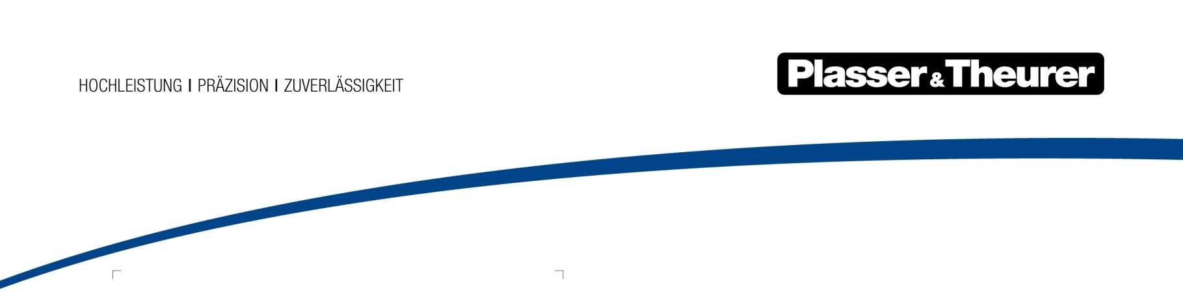

1 September 2019

New COO and CTO at Plasser & Theurer
Plasser & Theurer, Export von Bahnbaumaschinen, Gesellschaft m.b.H. has appointed Daniel Siedl as COO and Winfried Büdenbender as CTO, effective as of August 2019.
As early as 2017, Plasser & Theurer started restructuring its organisation to meet the future needs of the market. Having appointed new executives in Finance and Sales, Plasser & Theurer placed the focus on its core business - the design and production of track maintenance machines.
For this reason, two further executives have joined the company:
Dr. Winfried Büdenbender, CTO (Chief Technical Officer)
After completing his studies of Mechanical Engineering and Economic Sciences, Winfried Büdenbender held management positions in various companies in the technical sector.
Dr. Daniel Siedl, COO (Chief Operating Officer)
Daniel Siedl was managing director of ROBEL Bahnbaumaschinen GmbH (Germany) before he joined Plasser & Theurer. Prior to his new position, he was Head of Site Development and Process Optimisation.
Johannes Max-Theurer, CEO and owner, said “Our mission is to provide “Innovation for you”. This holds true for both our products as well as their design and production. For this reason, it is my pleasure to welcome Winfried Büdenbender and Daniel Siedl to our team, who will support us in further expanding our company’s core business.”

