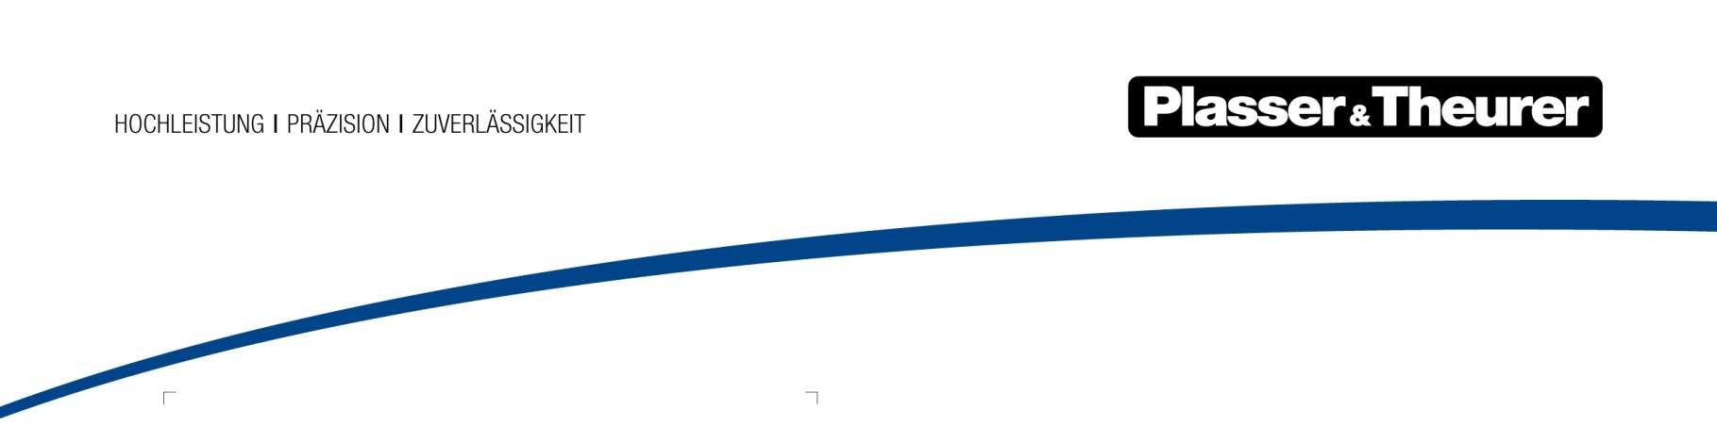

7 January 2019

New CSO at Plasser & Theurer
Plasser & Theurer, Export von Bahnbaumaschinen, Gesellschaft m.b.H., has appointed Thomas Schöpf as a Managing Director and Chief Sales Officer, effective from 1 January 2019.
Thomas Schöpf succeeds Gerhard Polterauer, who retired from Plasser & Theurer at the end of 2018. As a member of the management team and CSO of the world’s leading developer and manufacturer of track maintenance machines, Schöpf is responsible for all Sales Departments and Service Departments.
After graduating from a Higher Technical Education Institute for Electrical Engineering and completing his studies at Vienna University of Economics and Business, Ing. Mag. Thomas Schöpf joined the Kapsch Group in 1992, where he held various positions. Prior to his role at Plasser & Theurer, he was a Member of the Board and Chief Operating Officer of Kapsch CarrierCom AG.
Johannes Max-Theurer, CEO and owner, said “We are delighted to welcome Thomas Schöpf to our team. His international experience will help us to even further increase the customers’ benefit of our products and services.”

