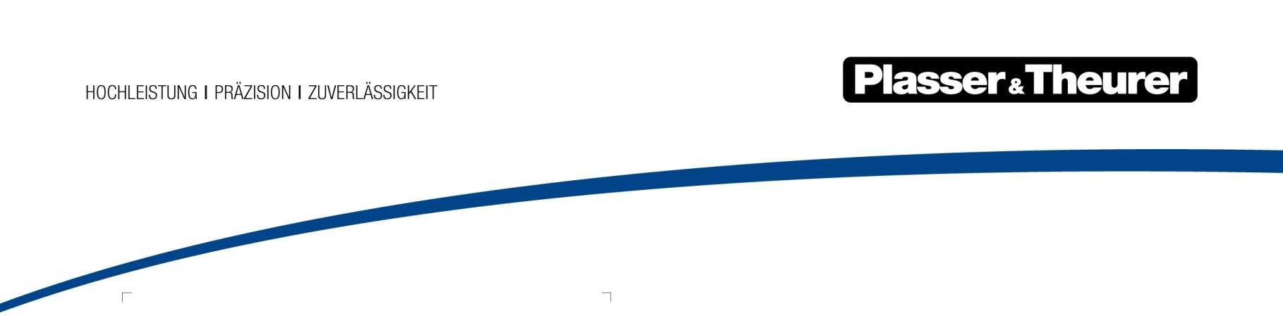

Vienna, 2018

INNOVATION FOR YOU
Cost-efficiency, sustainability and ergonomic design are at the core of far-reaching innovations allowing for a quantum leap into a new era of mechanised track construction and maintenance. Plasser & Theurer has greatly shaped this development. For the first time, the Austrian family business has built all-electric machines and machines with hybrid drive. Digitisation has created entirely new opportunities for both the operation and maintenance of machines. As a full-range supplier, Plasser & Theurer supports customers around the world with comprehensive after-sales services.
Since 1953, Plasser & Theurer has supplied around 16,000 machines to 109 countries. Today, the machine offer covers almost all works to be performed when maintaining, laying and renewing railway tracks. It ranges from simple tamping machines to 200 m long high-capacity machines. As a full-range supplier collaborating with 19 partner companies around the world,
Plasser & Theurer offers comprehensive after-sales services, covering training, spare parts supply and technical service.
With the introduction of the E³ machines, Plasser & Theurer has proven its position as the technology leader in the global market for track maintenance machines. E³ stands for economic, ecologic and ergonomic. As early as in 2015, Plasser & Theurer introduced the first two machines from the
E³ series: the 09-4X E³ Dynamic Tamping Express 4-sleeper tamping machine and the BDS 2000 E³ ballast management system. After decades of diesel-powered machines dominating track maintenance, they were the first machines with hybrid drive to be introduced onto the market. The machines are either supplied with the energy from the overhead line or powered by diesel engines.
On the occasion of the 2017 iaf, the world's largest trade fair in the field of track technology, the next steps into the future of track maintenance were introduced: the first all-electric tamping machine, the Unimat 09-4x4/4S E³ and the first maintenance vehicle for the overhead line with battery technology, the HTW 100 E³ .

New design for innovative technologies
The introduction of these new machines attracted a lot of attention. Not only because of the new design, implemented consistently for the first time, but also because of the great benefits resulting from the new technologies. In 2017, the Unimat 09-32/4S Dynamic E³ enabled savings of EUR 116 per hour of operation. Compared to catenary renewal and installation machines with conventional drives, the HTW 100 E³ reduces the noise emitted during works on the overhead line system by more than 20 dBA. Sometimes, staff talking on the work platforms is the loudest noise coming from the machine.
However, the new generation of machines not only benefits operators and railways, but also machine staff. The ergonomic design of the cabins provides a comfortable working environment. New control and assistance systems make it easier to operate the machines.

New digital tools for maximum performance
The far-reaching innovations in mechanised track maintenance not only involve new machine technologies, but also set new standards for the cost-efficient operation of machines. Developed by Plasser & Theurer, the PlasserSmartMaintenance initiative provides digital solutions that ensure greater transparency, connectivity and efficiency for both the maintenance of individual machines and entire machine fleets. For fleet management, PlasserDatamatic ensures transparency in real time. The most recent milestones are smart apps, such the SmartCatalog, which allows original spare parts to be found and inquired easily, and the first digital service booklet, the MachineMaintenanceGuide.
These ground-breaking innovations are important to Plasser & Theurer. Therefore, the company established P&T Connected. At the new subsidiary, data scientists use analyses, predictions and data-driven modelling to develop tools which allow operators to take decisions earlier, increase efficiency and save costs.

New service offers provide strong support for the entire service life
Plasser & Theurer offers dynamic after-sales services, which have been gaining importance in recent years. The customers are highly satisfied with the comprehensive training programme for machine staff, offered both at the parent company in Linz and at 19 partner companies around the world. Utmost importance is also placed on the supply of original spare parts. Every year, more than 7 million parts are sent from the logistics centre in Linz to all regions of the world. In addition, more than 30 warehouses all over the world ensure that our customers’ requests are met as quickly as possible.
The Technical Service rounds off the after-sales service offer. It ranges from on-site training to repairs and overhauls as well as complete maintenance services, providing comprehensive support for the entire service life of the machines.

Plasser & Theurer’s dynamic development strengthens the competitiveness of the Austrian family business that has been the technology leader in the global market for track maintenance machines for more than 60 years.

Plasser & Theurer in brief

- Founded in 1953
- Around 1,900 members of staff in Austria
- Around 4,000 members of staff worldwide, at 19 partner firms throughout the world and in Austria
- Range of products: Machines and systems for laying and installing, renewing and maintaining tracks and overhead lines
- More than 16,000 heavy-duty machines supplied to 109 countries
- Main factory in Linz
- Head office in Vienna
- Service, repair and spare parts depots all over the world
- Largest sale markets overall: Germany, USA, Great Britain, Japan, India, France, Austria, Spain, Brazil, Australia
- Customers: railway operators, construction firms, urban transport authorities, industrial and mine railways
- More than 2,000 active patents
- 12 international certificates/qualifications (e.g. ISO 9001, ISO 14001 and ISO 50001)

Contact:
Plasser & Theurer
Export von Bahnbaumaschinen Gesellschaft m. b. H.
1010 Wien, Johannesgasse 3
Phone: +43 1 51572-0
Fax: +43 1 5131801
Email: presse@plassertheurer.com
www.plassertheurer.com

“Plasser & Theurer” and “Plasser” are internationally registered trademarks.

